

**NAME:Huda Tayyab**

**SAP ID: 35483(BSSE)**

**CN LAB 7**

**Task 1:**

Send a ping command for both HUB and SWITCH network using command prompt in packet tracer and notice the results in simulation mode.

**Switch:**

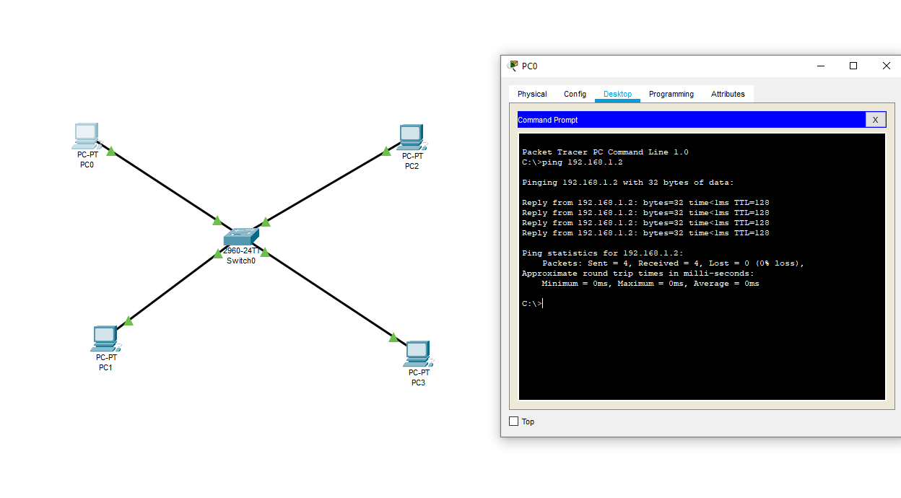

**HUB:**

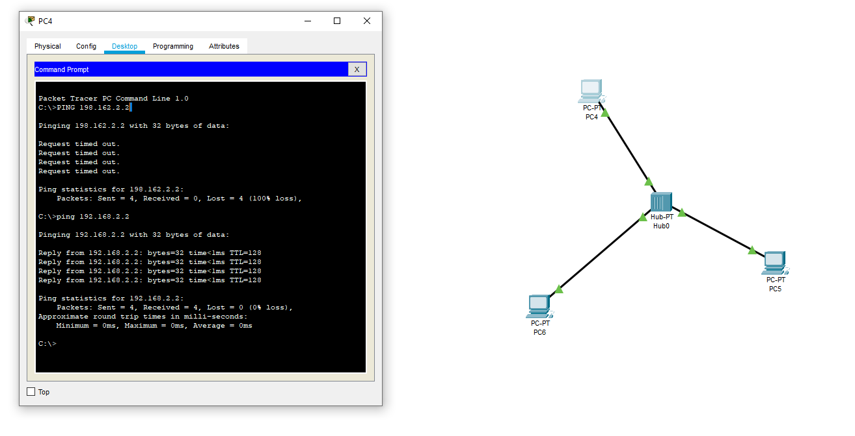

**Task 2:**

For the switched based network, set the new IP address and subnet mask for the PCs as follows.

|  |  |  |
| --- | --- | --- |
| **PC** | **IP ADDRESSES** | **SUBNET MASK** |
| PC0 | 192.168.1.36 | 255.255.255.224 |
| PC1 | 192.168.1.37 | 255.255.255.224 |
| PC2 | 192.168.1.38 | 255.255.255.224 |
| PC3 | 192.168.1.91 | 255.255.255.224 |

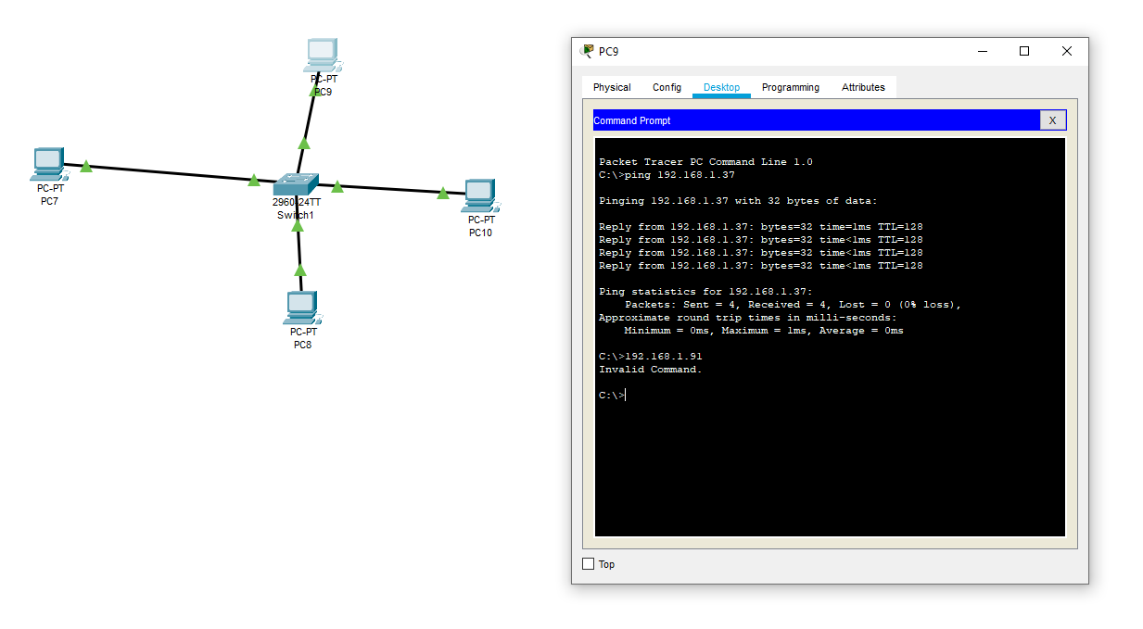

**Task 3:**

Create a star topology using a class A addressing scheme. Use Router to connect the end devices. Explain the behavior of the ping on each device.

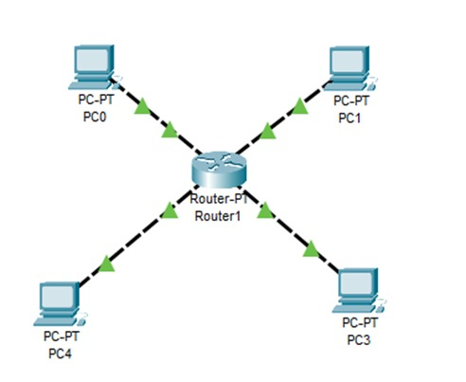

**Task 4:**

Create the topology shown in the below diagram

